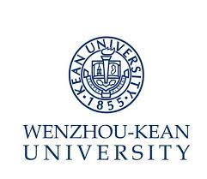
Job Description – – CNCC Course Instructor & Admin III (course: Approaching History)

Department: Chinese Curricula Center Reports to: Director (CNCC)
Position Summary

- Assist in establishing CNCC curriculum, assist in organizing the teaching;
- Formulate teaching plans, course outlines and instruct on course Approaching History and responsible for the relative research work;
- Assist in organizing Lecture Series of Chinese National Conditions & Culture;
- Provide students with developmental suggestions according to timely evaluation;
- Complete other teaching and administration work assigned by superiors.

Qualification:
- Master or above, major in Humanities and Social Sciences or Marxist theory（Main research direction: History）;
- CET 6 or above, certain English writing and speaking ability, strong teaching and research ability

Preferred Qualification:
- With at least three years' relative teaching experience in Sino-foreign higher education institutions.

岗位书 – 教学与管理III 《古与今》
部门：国情中心 汇报：部门负责人
岗位职责：
- 协助建设国情与文化教育体系，协助国情与文化教学组织；
- 制定《古与今》教学大纲，承担课程教学及相关科研；
- 协助组织国情国学系列讲座；
- 对学生进行定期考核和评估，并给出一定发展建议；
- 完成交办的其他相关教学及行政工作。

聘任条件：
必备条件
- 硕士及以上学位，人文社会科学类专业（史学方向）、马克思主义理论一级学科相关专业（历史方向）；
- 大学英语六级以上，一定英文书面及口头表达能力，较强教学及科研能力。

优先条件
- 具备3年以上中外合作高校思政课教学经历。

