Document authentication for use in China.
Here is the outline of three major steps for document authentication for China:

- Notary: For non-government documents such as affidavit, power of attorney, bank letter, etc., a notary public must notarize the document first; for government documents such as birth certificates, good standing certificates, etc., you will need to obtain a certified copy from the state; notary is not required.

- State Authentication: The State Authentication Office must certify the notary seal or the certified copy by adding a statement page with big state seal. Some states require county clerk to certify the notary seal first.
Please find State authentication Sample:
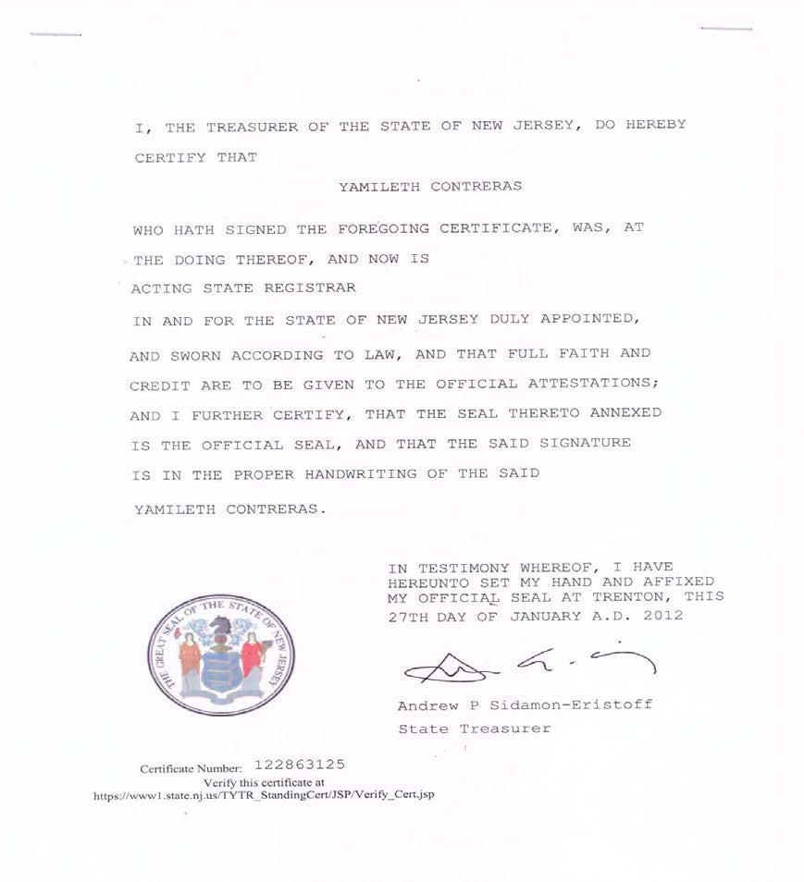
Once your documents are authenticated by the Secretary of State; the staples located at the top of the document must not be removed, or it will invalidate the document.

- Consulate Authentication: The Chinese Embassy or Consulate will verify signature and seal from the Secretary of State Office. Once verified, the Chinese Embassy or Consulate official will add the authentication seal and signature to the document and it will be authorized for use in China.
Please find Chinese/ consulate authentication sample:
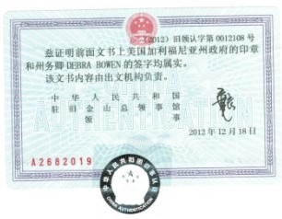

If you are traveling with family members who will reside with you:
You must have the following documents authenticated by the Chinese embassy/ consulate. The document(s) must first be notarized and authenticated by the State Authentication Office, then further authenticated by the Chinese Embassy or Chinese Consulate accordingly.

1.For a Spouse, please provide the following document:
  - Marriage certificate authenticated by a Chinese embassy
2.For a Child, please provide the following (Please note that adult supervision will be required for all minor children under the age of 18):
  - Birth certificate(s) authenticated by a Chinese embassy

