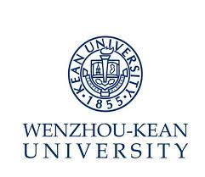
Job Description – – CNCC Course Instructor & Admin II (Course: Inheritance and Internationalization of Chinese Culture)

Department: Chinese Curricula Center Reports to:Director(CNCC)

Position Summary

- Assist in establishing CNCC curriculum, assist in organizing the teaching;
- Formulate teaching plans, course outlines and instruct on course Inheritance and Internationalization of Chinese Culture and responsible for the relative research work;
- Provide students with developmental suggestions according to timely evaluation;
- Responsible for teaching Chinese and Chinese culture to speakers of other languages;
- Complete other teaching and administration work assigned by superiors.

Qualification:
- Master or above, major in Chinese language or related;
- CET 6 or above or strong English writing and speaking ability, strong teaching and certain research ability.

Preferred Qualification:
- With at least three years' relative teaching experience in Sino-foreign higher education institutions.

岗位书 – 教学与管理II 《文化传承与国际化》
部门：国情中心 汇报：部门负责人
岗位职责：
- 协助建设国情与文化教育体系，协助国情与文化教学组织；
- 制定《文化传承与国际化》教学大纲，承担课程教学及相关科研；
- 对学生进行定期考核和评估，并给出一定发展建议；
- 负责对外汉语及文化教学；
- 完成交办的其他相关教学及行政工作。

聘任条件：
必备条件
- 硕士及以上学位，中国语言文学类专业；
- 大学英语六级以上或流利英文书面及口头表达能力，较强教学能力，一定科研能力。

优先条件
- 具备3年以上中外合作高校思政课教学经历。

